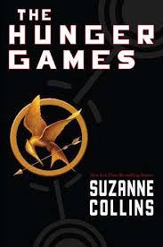
Name: Monty San Juan
Date: 1/12/17
Period: 1
Book Review
Book Review for The Hunger Games

Author of Book: Suzanne Collins
Number of Pages: 374
Year Book was Published: 2008
Main Characters:
- Katniss Everdeen
- Peeta Mellark
- Haymitch Abernathy
- Effie Trinket
- Gale

Summary of Events:
The Hunger Games, the Capitol forces each of Panem's 12 districts to choose two teenagers to participate in the Hunger Games, a gruesome, televised fight to the death. In the 12th district, Katniss Everdeen steps in for her little sister and enters the Games, where she is torn between her feelings for her hunting partner, Gale Hawthorne, and the district's other tribute, Peeta Mellark, even as she fights to stay alive.

Important Quote (include page number):
“I volunteer!” I gasp. “I volunteer as tribute!” pg.22
Why This Quote is Important:
This quote is important because it sets the plot in motion and the way it went, and the rest of the book is about how Katniss survives the Hunger Games. This is also important because volunteers in her district aren’t really heard of and that the people who join are usually poor and don’t win.

Would You Recommend this Book to Someone (circle yes or no)? yes / no

Why You Would Recommend or Not Recommend This Book:

I would recommend this book because it just makes you want to keep reading due to the action of Katniss’ survival tactics and what she does to live. Overall, it shows some important topics that go around today of the inequalities between the poor and rich.

How Many Stars Would You Give This Book (out of 5, with 5 being the best)?
3/5 Stars

